

<First Name> <Surname>
<Address 1>
<Address 2>
<Town>
<Postcode>

Dear <First Name>
You could be at risk of developing type 2 diabetes.
We are writing to you because you have had a blood test in the past 12 months that showed a higher-than-normal blood sugar level, which means you could be at risk of developing type 2 diabetes in the future.
Your NHS number: [ENTER PATIENT NHS NUMBER]
Your HbA1C/FPG reading: [ENTER PATIENT HbA1C or FPG READING]
Date of blood result: [ENTER DATE OF HbA1C or FPG TEST]
Type 2 diabetes is a serious condition that, if left untreated, can lead to long-term health problems. The good news is that, if you act now, type 2 diabetes is preventable in most cases through small lifestyle changes.
Free support is available at your local Healthier You, NHS Diabetes Prevention Programme (DPP). This is a nine-month programme funded by the NHS to support you in making healthy lifestyle changes. It is completely free to use and convenient for everyone; with local group sessions, online tailored courses or digital-only options.
Across the country over 100,000 people have already reversed their risk of developing type 2 diabetes through the Healthier You programme.
REDUCE YOUR RISK OF TYPE 2 DIABETES AND BOOK YOUR PLACE NOW!
Booking is essential. You can’t join after the course has started.
Healthier You courses are running in your local area. To secure your place you can:
- Self-register for the programme by visiting www.healthieryou.org.uk/gp
- Call the Healthier You team on 0333 047 9999

For either of the above options please ensure you have a recent height and weight measurement available.
Alternatively, you can contact your GP practice and ask to be referred to the Healthier You programme, and the practice will forward your details to the Healthier You team.

For more information about the programme please visit www.healthieryou.org.uk, call the Healthier You team on 0333 047 9999 or contact your GP practice.

Yours sincerely,
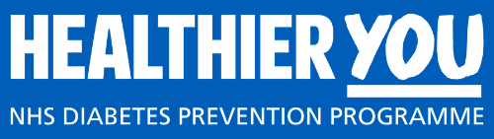
[Name of health care professional]

